

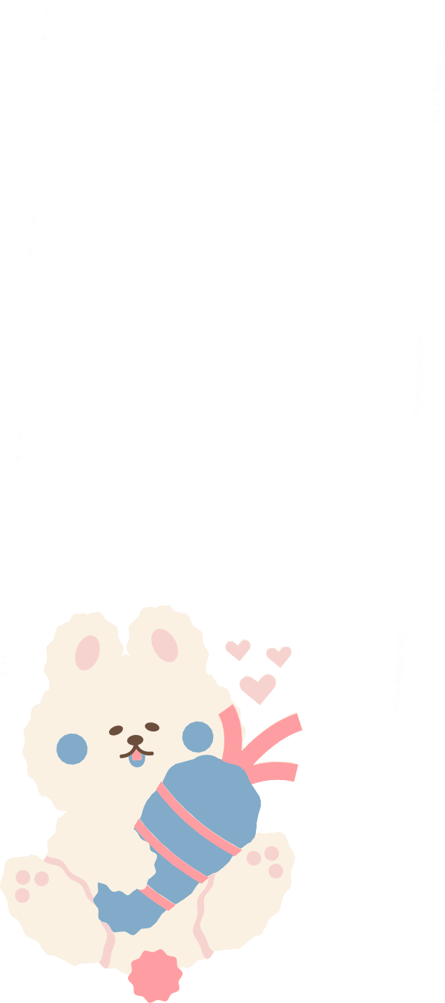
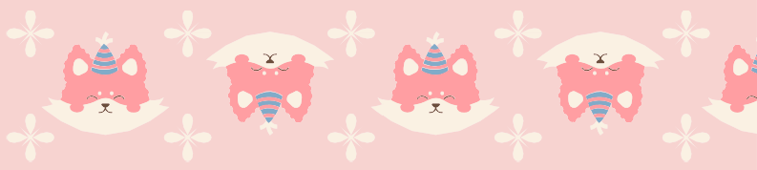
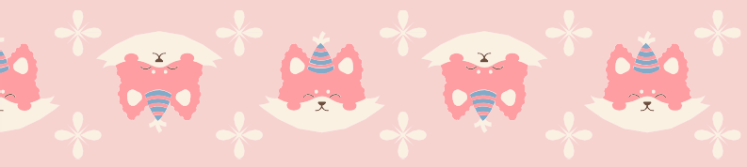







H i th e r e ,
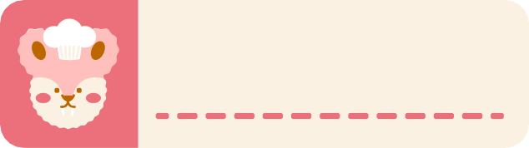

m y n a m e i s
a b o u t m e

Olivia Wilson

a b o u t m e

I am a young and ambitious woman on a journey to discover my true potential and make a positive impact in the world. Let me take you through the various aspects that define me and make me who I am.

F u n fa c ts

I don't like vegetables, especially cucumber.
I'm obsessed with hats—A QUIRKY COLLECTION GALORE.
I'm a dancing diva, GUARANTEED SURPRISE MOVES.

F a v o r i te c o l o r s

