about me!

WHAT YOU MUST KNOW ABOUT ME:

t eM e YouNG eND
eMBtrtous woMeN oN e coueNcY ro
Dtscovce MY reuc
9orcNrtel eND Meuc e 9ostrtvc tM9ecr tN
+t
mY Nemc ts
r+c woelD. lcr Mc reuc You r+eouG+
OLIVIA WILSON
r+c veetous es9ccrs r+er DcctNc Mc eND Meuc Mc w+o t eM.


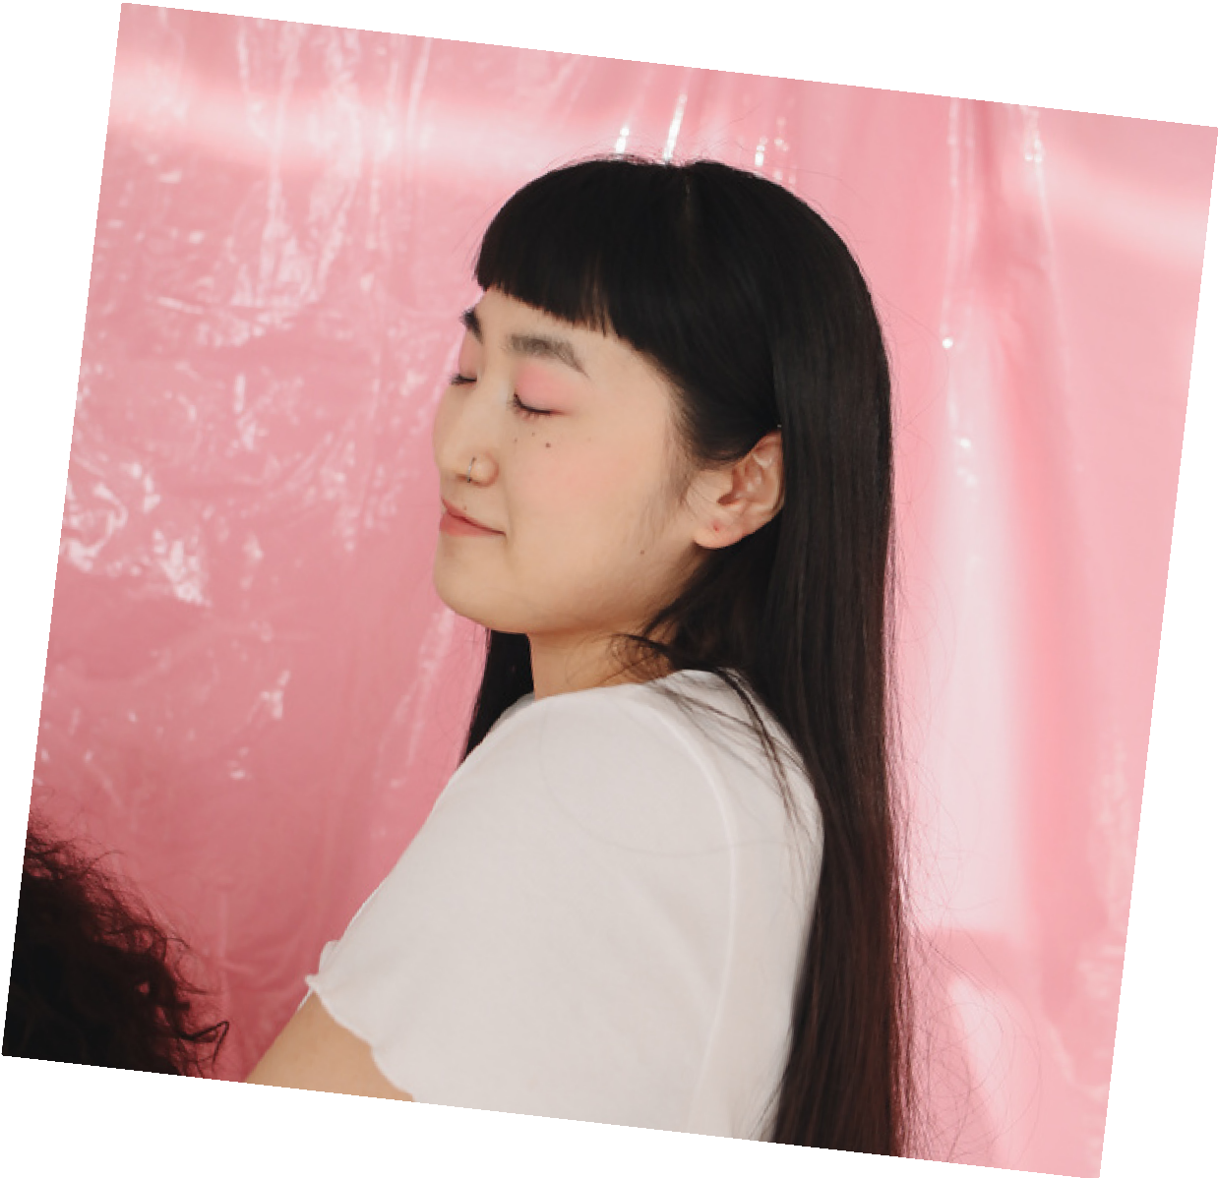
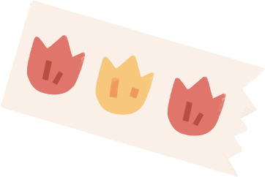












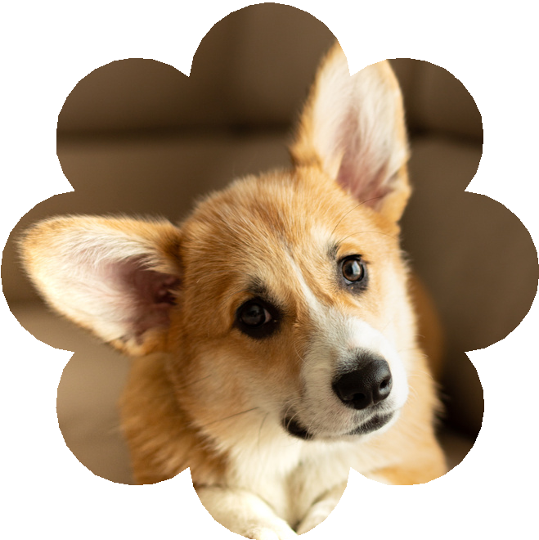

FUN FACT:
t DoNtr ltuc vcGcreBlcs: cs9cctellY cucuMBce.
ttM oBscsscD wtr+ +ers: e auteuY collccrtoN Geloec.
ttM e DeNctNG Dtve:
GueeeNrccD sue9etsc Movcs.
t +evc r+ecc Bcsr cetcNDs eND r+cY eec ell BoYs.

FAVOURITE COLOR

MY PET:
MY 9cr DoG ts e coeGt. +c ts vceY cuNNY eND +es e sMell retl. wc
+evc NeMcD +tM coNNY. +c +es
BccN wtr+ us coe r+c lesr s Ycees.

