[CLAUDIA ALVES]
[GRAPHIC DESIGNER]
[@REALLYGREATSITE]

CLAUDIA ALVES

WORK EXPERIENCE SKILLS

LICERIA & CO.
2030_2032

STUDIO SHODWE
2032_2035

Job Position

Job Position
TYPOGRAPHY

PHOTOGRAPHY

VIDEO EDITING

LARANA, INC.
2035-2038

LANGUAGES

ENGLISH

SPANISH KOREAN

REFERENCE

OLIVIA WILSON
CEO | Studio Shodwe
hello@reallygreatsite.com
+123-456-7890
Job Position

LOREM IPSUM DOLOR SIT AMET, CONSECTETUR ADIPISCING ELIT. NULLAM PHARETRA IN LOREM AT LAOREET. DONEC HENDRERIT LIBERO EGET EST TEMPOR, QUIS TEMPUS ARCU ELEMENTUM. IN ELEMENTUM ELIT AT DUI TRISTIQUE FEUGIAT.

CsauPia Asxẹs

MOTION GRAPHIC

EDUCATION

REALLY GREAT UNIVERSITY
JUNE 2030-
JULY 2034
Enter Your Degree

REALLY GREAT UNIVERSITY
JUNE 2035-JULY 2038
Enter Your Degree

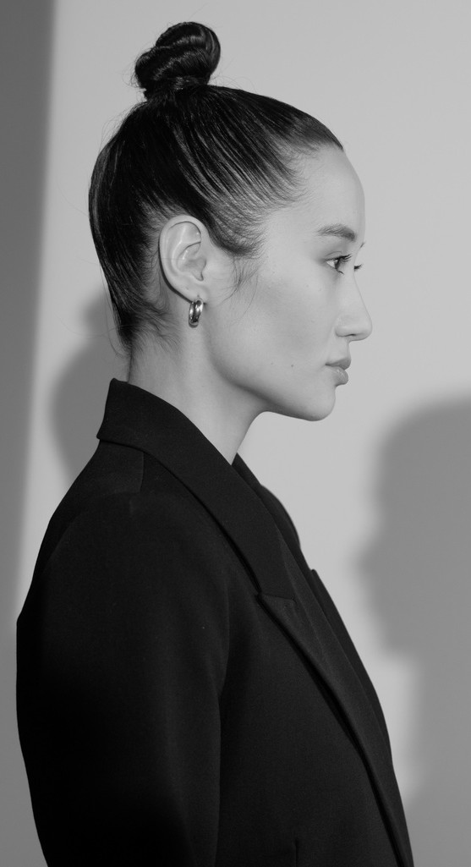



@REALLYGREATSITE | PHONE | ADDRESS
[CLAUDIA ALVES] | [+123-456-7890] | [123 ANYWHERE ST., ANY CITY]

